Trial 3 RGB Growth-Rate and Treatment Comparison — Short Report
This report summarises the Trial 3 RGB visible-emergence and green-cover analysis. The purpose of this script was to convert the cell-level outputs from Script 04 into tray-level and treatment-level growth comparisons. The report also documents the generated CSV, Excel, chart, PDF, and Word outputs so that the results can be interpreted and reused in the final internship report.
The analysis is based on visible seedling evidence detected from RGB images. Therefore, the results should be interpreted as visible emergence and image-derived green-cover measurements, not as direct biological germination measurements below the soil surface.

1. Input data and processing summary
The RGB comparison used 4 trays, with each tray containing 70 grid cells. The adjusted cell table contained 5880 cell-day records. The analysis covered the corrected seven observation days from Day 1 (29/06/2026) to Day 7 (07/07/2026).
A total of 198 Day 7 cell records were flagged for adjusted estimation. These were cells where earlier visible green evidence was detected but Day 7 showed missing or no current green evidence. The adjustment was made only in the separate adjusted output columns; the observed Day 7 values were preserved unchanged.
The main metrics calculated in this script were final tracked visible emergence percentage, observed RGB green-cover percentage, adjusted RGB green-cover percentage, Day 1 to Day 7 growth rates, Day 6 to Day 7 change, possible Day 7 missing cells, and an overall descriptive RGB performance score.

2. Tray-level performance summary
The highest adjusted RGB performance score was recorded by Tray 8 (Microbes | Heat | Dynamic Heat). Its adjusted RGB score was 70.75. This ranking combines final visible emergence, final adjusted RGB green-cover, growth-rate behaviour, and emergence timing into one descriptive score.
The table below lists the tray-level ranking using the adjusted RGB performance score. This table is useful for identifying the trays that performed best overall after accounting for possible Day 7 missing crop issues.
Tray | Microbe Status | Treatment | Environment Group | Final Tracked Emergence Percent | Final Adjusted Green Cover Percent | Day7 Imputed Cells | Overall Adjusted Rgb Score | Overall Adjusted Rgb Rank
Tray 8 | Microbes | Heat | Dynamic Heat | 100.0 | 6.423 | 8 | 70.747 | 1
Tray 4 | No Microbes | Heat | Dynamic Heat | 100.0 | 4.791 | 18 | 60.196 | 2
Tray 6 | Microbes | Heat | Dynamic Heat | 97.143 | 7.16 | 0 | 53.449 | 3
Tray 11 | No Microbes | Heat | Dynamic Heat | 98.571 | 3.975 | 18 | 47.753 | 4
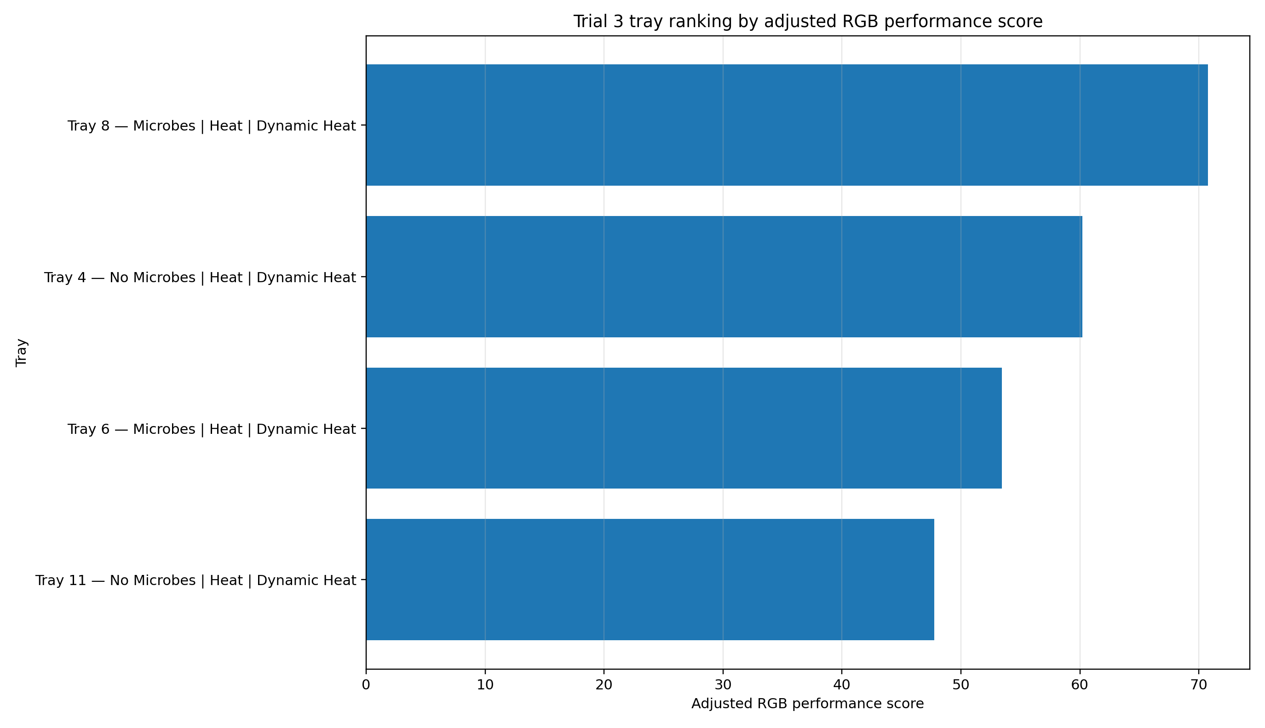

3. Microbes vs No Microbes comparison
For final adjusted RGB green-cover, the highest mean value in the microbe status comparison was recorded by Microbes (6.79).
For overall adjusted RGB performance score, the highest mean value in the microbe status comparison was recorded by Microbes (62.10).
This comparison groups trays by Microbes and No Microbes. It helps evaluate whether the microbial treatment was associated with stronger visible emergence or higher green-cover development across the trial.
Group | Tray Count | Mean Final Tracked Emergence Percent | Mean Final Adjusted Green Cover Percent | Mean Adjusted Green Cover Rate Day1 To Day7 Pp Per Day | Mean Overall Adjusted Rgb Score
Microbes | 2 | 98.571 | 6.792 | 0.848 | 62.098
No Microbes | 2 | 99.286 | 4.383 | 0.547 | 53.975
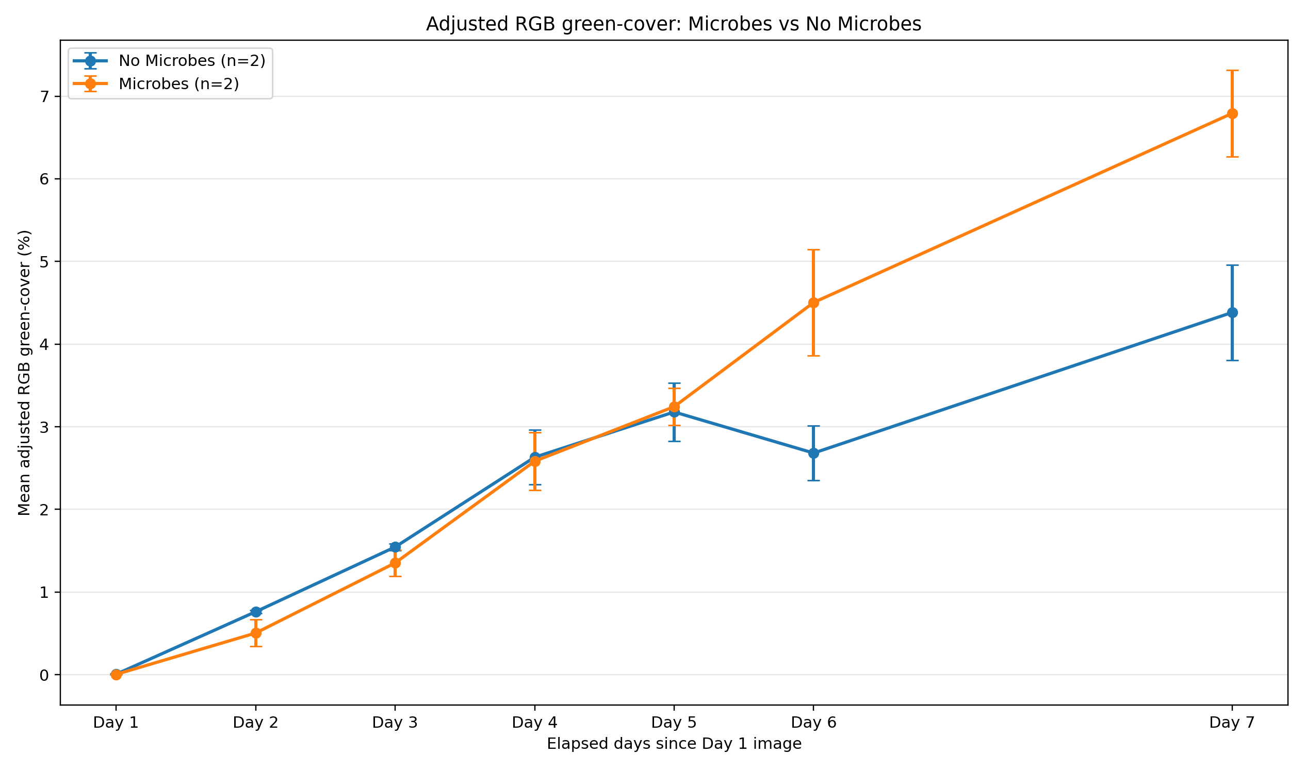
The Microbes vs No Microbes green-cover trend chart shows how the mean adjusted RGB green-cover changed across the seven observation days. This chart is useful for checking whether one group developed faster or maintained stronger green-cover over time.

4. Ideal vs Heat vs Moisture comparison
For final adjusted RGB green-cover, the highest mean value in the treatment type comparison was recorded by Heat (5.59).
For overall adjusted RGB performance score, the highest mean value in the treatment type comparison was recorded by Heat (58.04).
This comparison groups trays by treatment type: Ideal, Heat, and Moisture. The Ideal treatment represents trays kept fully inside or outside without the scheduled heat or moisture stress. Heat trays were moved according to the heat-treatment schedule, while Moisture trays followed the restricted watering schedule.
Group | Tray Count | Mean Final Tracked Emergence Percent | Mean Final Adjusted Green Cover Percent | Mean Adjusted Green Cover Rate Day1 To Day7 Pp Per Day | Mean Overall Adjusted Rgb Score
Heat | 4 | 98.929 | 5.587 | 0.698 | 58.036
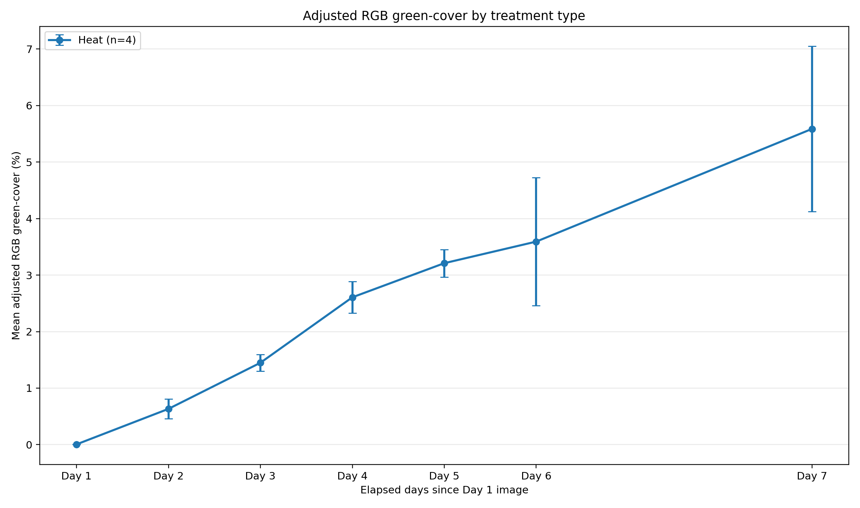
The treatment green-cover chart compares Ideal, Heat, and Moisture groups over time. It is useful for observing whether stress treatments reduced growth, delayed emergence, or produced recovery patterns later in the trial.

5. Inside vs Outside comparison for Ideal and Moisture trays
A direct Inside vs Outside comparison was performed only for Ideal and Moisture trays because these treatments had fixed placement. Heat trays were excluded from this direct comparison because their location changed during the heat-treatment schedule. This prevents dynamic Heat trays from being incorrectly treated as permanently inside or outside.
Treatment | Inside Tray Count | Outside Tray Count | Inside Final Emergence Percent | Outside Final Emergence Percent | Inside Minus Outside Final Emergence Pp | Inside Final Adjusted Green Cover Percent | Outside Final Adjusted Green Cover Percent | Inside Minus Outside Adjusted Green Cover Pp | Inside Minus Outside Adjusted Growth Rate Pp Per Day | Interpretation
Ideal | 0 | 0 | nan | nan | nan | nan | nan | nan | nan | Insufficient data for comparison.
Moisture | 0 | 0 | nan | nan | nan | nan | nan | nan | nan | Insufficient data for comparison.
For Ideal trays, the inside-minus-outside difference in adjusted Day 7 RGB green-cover was N/A percentage points. Interpretation: Insufficient data for comparison.
For Moisture trays, the inside-minus-outside difference in adjusted Day 7 RGB green-cover was N/A percentage points. Interpretation: Insufficient data for comparison.
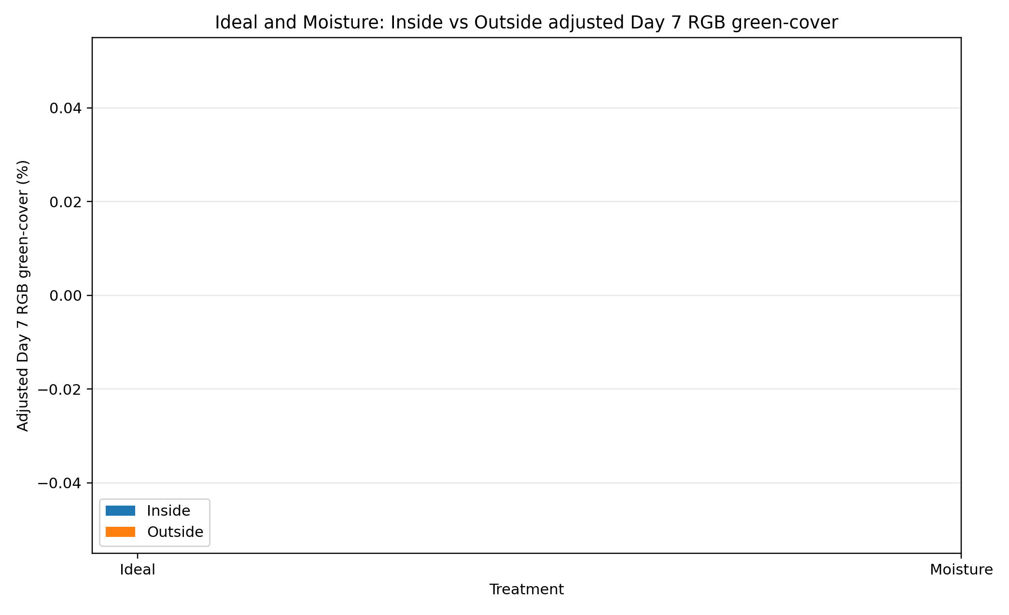
The Inside vs Outside green-cover chart compares the adjusted final green-cover percentage for Ideal and Moisture trays. This chart directly answers whether fixed inside placement or fixed outside placement was associated with stronger visible crop development within those treatment types.
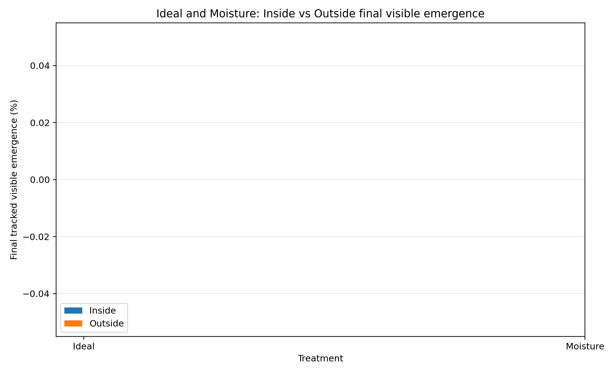
The Inside vs Outside emergence chart compares final tracked visible emergence. It is different from the green-cover chart because emergence measures how many cells showed visible seedlings, while green-cover measures the relative amount of green plant area inside the cell zones.

6. Observed vs adjusted Day 7 results
The observed Day 7 results represent what was actually visible in the final images. The adjusted Day 7 values are a separate scenario created for growth-rate comparison when a cell had earlier visible crop but no green evidence on Day 7. This adjustment is important because some seedlings may have been eaten by bugs or otherwise disappeared before the final image set.
The observed and adjusted values are not mixed silently. The adjusted cell table contains columns such as day7_imputed, imputation_reason, imputation_method, previous_growth_rate_pp_per_day, and adjustment_difference_pp so that every estimated value can be traced.
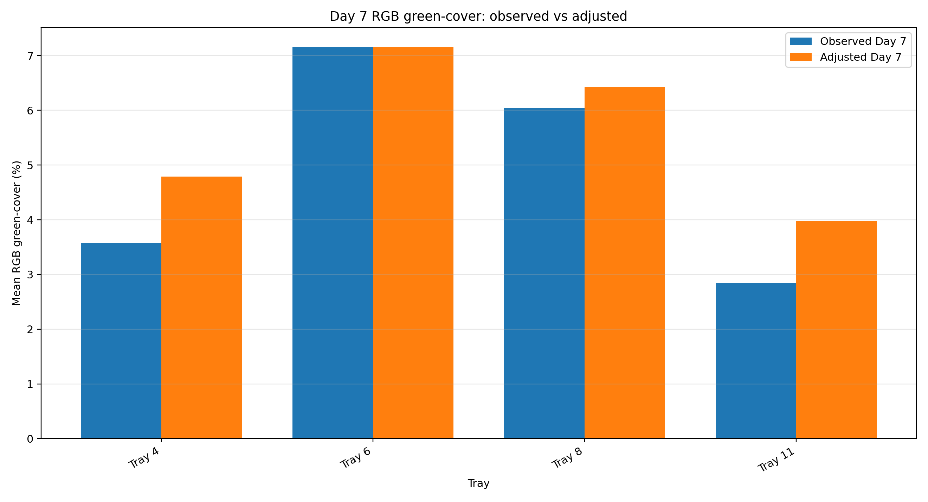
The observed vs adjusted Day 7 chart shows how much the final tray-level green-cover changed after applying the Day 7 missing-crop adjustment. Large differences indicate trays where many cells had earlier growth but lower visible green area in the final image.
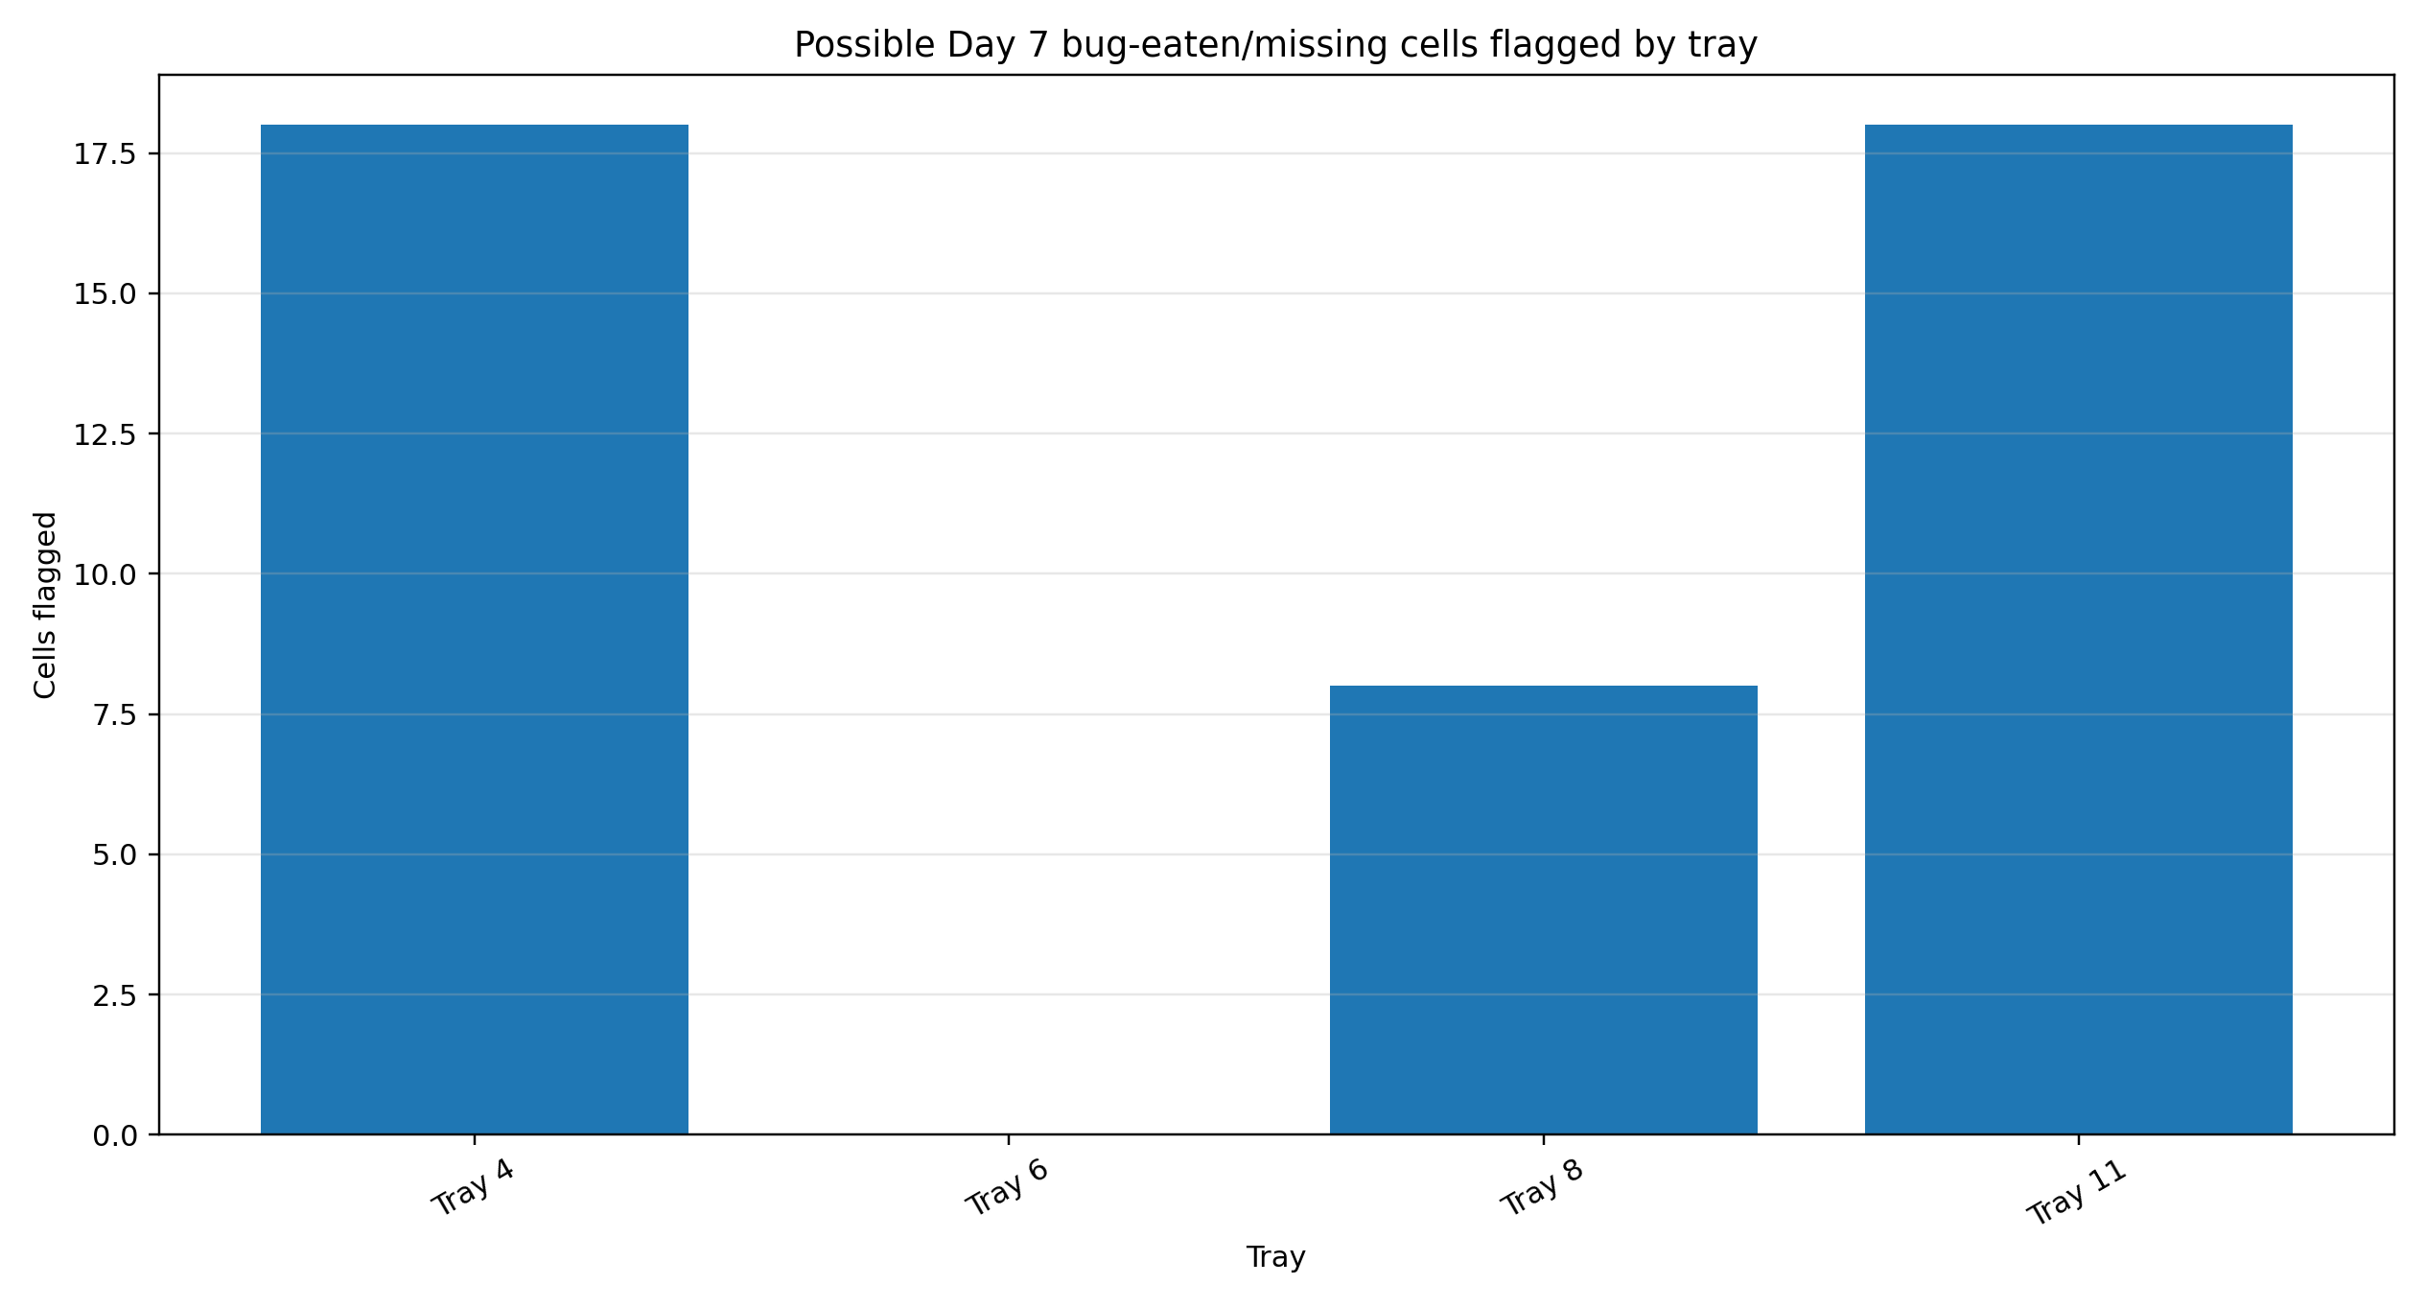
The possible bug-eaten cell chart shows the number of Day 7 cells flagged for adjustment in each tray. This chart helps identify which trays were most affected by missing final-day crop evidence.

7. Description of generated CSV files
cell_growth_with_day7_adjustment.csv: The full cell-level dataset after Day 7 adjustment processing. It preserves observed green-cover values and adds adjusted green-cover columns, imputation flags, and imputation reasons for cells affected by possible Day 7 crop disappearance.
tray_daily_rgb_metrics.csv: A tray-by-day summary table. It contains daily visible emergence percentage, observed green-cover percentage, adjusted green-cover percentage, newly emerged cells, and Day 7 imputed cell counts for each tray.
tray_growth_metrics.csv: A tray-level growth summary. It includes final emergence, final observed and adjusted green-cover, Day 1 to Day 7 growth rates, Day 6 to Day 7 changes, T50 timing, and overall RGB performance scores.
group_daily_metrics.csv: A group-by-day trend table. It summarises daily group averages for Microbes vs No Microbes, treatment groups, treatment-by-environment groups, and other comparison categories.
group_growth_metrics.csv: A group-level final comparison table. It summarises final performance and growth-rate metrics for each treatment or comparison group.
inside_outside_comparison_ideal_moisture.csv: A dedicated comparison table for Ideal and Moisture trays only. It compares Inside vs Outside final emergence, adjusted green-cover, growth rate, and overall adjusted RGB score.
possible_day7_bug_eaten_cells.csv: A filtered table containing only cells that were flagged for Day 7 adjustment because they had earlier visible green evidence but were missing or not visible on Day 7.
heat_phase_response.csv: A descriptive summary of Heat tray performance across the heat-treatment phases, including inside-before-heat, outside heat exposure, and inside recovery.
moisture_phase_response.csv: A descriptive summary of Moisture tray performance across watering and dry phases.

8. Description of Excel workbook
The Excel workbook rgb_growth_treatment_report.xlsx combines the main CSV outputs into one file with multiple sheets. It is the easiest file to inspect manually because it contains tray-level, group-level, inside-vs-outside, Day 7 adjustment, heat-phase, and moisture-phase outputs in one place.
Tray Growth Metrics sheet: Contains one row per tray and is the main sheet for ranking trays by final performance, growth rate, and adjusted RGB score.
Tray Daily Metrics sheet: Contains one row per tray per observation day and is useful for checking daily progression.
Group Daily Metrics sheet: Contains group-level daily trends used to create line charts.
Group Growth Metrics sheet: Contains final group-level comparison metrics for Microbes, treatments, and treatment-environment groups.
Inside Outside Compare sheet: Contains the dedicated Ideal and Moisture Inside vs Outside comparison.
Day7 Imputed Cells sheet: Contains only the cells where adjusted Day 7 values were estimated.
Heat Phase Response sheet: Summarises performance of Heat trays across the heat-treatment movement phases.
Moisture Phase Response sheet: Summarises performance of Moisture trays across watering and non-watering phases.

9. Description of generated charts
01_microbes_visible_emergence_trend.png: Shows the tracked visible emergence trend for Microbes and No Microbes groups across observation days.
Chart file: 01_microbes_visible_emergence_trend.png
02_microbes_adjusted_green_cover_trend.png: Shows adjusted RGB green-cover over time for Microbes and No Microbes groups.
Chart file: 02_microbes_adjusted_green_cover_trend.png
03_treatment_visible_emergence_trend.png: Shows tracked visible emergence trends for Ideal, Heat, and Moisture treatments.
Chart file: 03_treatment_visible_emergence_trend.png
04_treatment_adjusted_green_cover_trend.png: Shows adjusted RGB green-cover trends for Ideal, Heat, and Moisture treatments.
Chart file: 04_treatment_adjusted_green_cover_trend.png
05_day7_observed_vs_adjusted_green_cover_by_tray.png: Compares observed Day 7 green-cover with adjusted Day 7 green-cover for each tray.
Chart file: 05_day7_observed_vs_adjusted_green_cover_by_tray.png
06_adjusted_rgb_tray_ranking.png: Ranks trays by overall adjusted RGB performance score.
Chart file: 06_adjusted_rgb_tray_ranking.png
07_day7_possible_bug_eaten_cells_by_tray.png: Shows how many cells in each tray were flagged as possible Day 7 missing or bug-eaten cells.
Chart file: 07_day7_possible_bug_eaten_cells_by_tray.png
08_inside_outside_adjusted_green_cover_ideal_moisture.png: Compares Inside vs Outside adjusted Day 7 RGB green-cover for Ideal and Moisture trays.
Chart file: 08_inside_outside_adjusted_green_cover_ideal_moisture.png
09_inside_outside_emergence_ideal_moisture.png: Compares Inside vs Outside final visible emergence for Ideal and Moisture trays.
Chart file: 09_inside_outside_emergence_ideal_moisture.png

10. Interpretation and limitations
The results are useful for identifying visual growth trends and treatment differences in Trial 3. However, they should be interpreted carefully. The measurements are based on image-derived visible green area, not direct plant biomass or calibrated reflectance. Lighting, image quality, crop overlap, and cell visibility can affect RGB green-cover estimates.
The Day 7 adjustment is a practical correction for likely bug-eaten or missing seedlings. It should be used only for adjusted growth-rate comparison, while the observed Day 7 results should remain the source for reporting what was actually visible in the images.
The Inside vs Outside comparison is restricted to Ideal and Moisture trays because Heat trays were moved between environments. Including Heat trays in a fixed Inside vs Outside comparison would be misleading.
Because each treatment group contains a small number of trays, these results should be treated as descriptive evidence rather than formal statistical proof. The later multispectral scripts should be used to check whether NDVI and NDRE trends support the RGB results.

